| ORTON WISTOW PRIMARY SCHOOLCURRICULUM PLANLine  | Academic Year: | 2024/25 | Term: | Spring | | --- | --- | --- | --- | | Year Group: | 6 | Topic Title: | Peterborough in WWI and WWII | |
| --- | --- | --- | --- | --- | --- | --- | --- | --- |

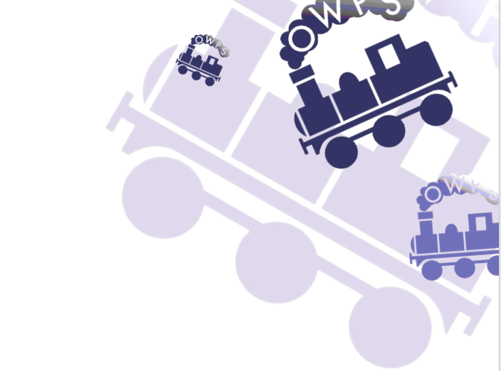

| **Subject** | **Learning** |
| --- | --- |
| **English -** Reading | * Reading is taught using resources from PiXL. Looking at how to use inference, deduction, key vocabulary and analysis of a text. These resources look at and teach the children how to answer questioning based on a text, so the skills can be applied into a range of lessons. |
| **English –** Class Texts | * Harriet Tubman - we will look at this short text from the Little People Big Dreams series in the first two weeks of the term. * Moth by Isabel Thomas |
| **English -** Writing | * Power of Reading Text – Stay Where You Are and Then Leave (John Boyne) will set the foundations for Spring 1, where a range of writing styles will be covered, such as; Narrative and Essay styles, incorporating the use of inverted commas. * Power of Reading Text - Rose Blanche (Roberto Innocenti/Ian McEwan) Speeches and Campaign Writing linked to WWII |
| **English –** Phonics/Spelling | * Spelling Rules 11-20 will be taught over the Spring term. * These include:   ‘j’ ending, ‘ll’ ending, contractions, suffixes after ‘y’, less, ment, ful and ness suffixes, ‘ly’ suffix, tion/sion, sure/ture, prefixes, ous/ious  We will continue to use bundles from Sir Linkalot, but also have a real focus on the Y5/6 Statutory Spellings, in preparation for SATs. |
| **Mathematics** | * At the start of the term we will cover learning on   + Statistics   + Ratio and Proportion: Ratio   + Algebra   + Geometry: Investigating Angles, Opposite Angles, Angles in a Triangle, Angles in a Quadrilateral   + Geometry: Describing Position and Plotting coordinates, Describing Translations. * We will also continue to practice and recap a range of different methods for solving arithmetic and reasoning questions. Towards the end of the spring term we will focus on recapping key learning form Key Stage in preparation for the SATS tests in May. |
| **Science** | **Living things and their habitats**   * Describe how living things are classified into broad groups according to common observable characteristics and based on similarities and differences, including micro-organisms, plants and animals * Give reasons for classifying plants and animals based on specific characteristics.   **Animals, including humans**   * Identify and name the main parts of the human circulatory system, and describe the functions of the heart, blood vessels and blood * Recognise the impact of diet, exercise, drugs and lifestyle on the way their bodies function * Describe the ways in which nutrients and water are transported within animals, including humans. |
| **Computing** | **Quizzing/Barefoot**   * Pupils are introduced to the history of computing and, in particular, how computers were used as code-cracking devices in World War II. Pupils learn about Alan Turing and become code crackers themselves. They then create their own movie about code cracking. |
| **History** | **Local History Study Unit - Peterborough in World War 1 & 2**   * Unlike all other areas of study, Local History has no real prescribed content. Y6 investigation will begin with the war memorial in Alwalton church and consider what it tells us about our local area during the First and Second World War. |
| **Geography** | **Our Changing World**  **Locational knowledge –**   * Locate the world’s countries, using maps to focus on Europe (including the location of Russia) and North and South America, concentrating on their environmental regions, key physical and human characteristics, countries, and major cities. * Name and locate counties and cities of the United Kingdom, geographical regions and their identifying human and physical characteristics, key topographical features (including hills, mountains, coasts and rivers), and land-use patterns; and understand how some of these aspects have changed over time.   **Human and physical geography - describe and understand key aspects of:**   * Physical geography, including: climate zones, biomes and vegetation belts, rivers, mountains, volcanoes and earthquakes, and the water cycle. * Human geography, including: types of settlement and land use, economic activity including trade links, and the distribution of natural resources including energy, food, minerals and water. |
| **Art & Design** | **Identity**   * In our Art lessons we will be exploring how a range of different artists use portraits to show their identity. We will move onto creating our own layered self portraits inspired by some of the artists we have been looking at. |
| **Music** | **A New Year Carol**   * We will be learning to sing and perform A New Years Carol by Benjamin Britten. |
| **Design Technololgy** | **Textiles** - Make Do and Mend  Children will research inspirational designers and collect ideas for their own design. They will create objects (such as a cushion) that employ a seam allowance. Join textiles with a combination of stitching techniques (such as back stitch for seams and running stitch to attach decoration) and evaluate their product looking at how much they would cost their item for and how it fits the design brief. |
| **PE** | **Term 1 Netball and Hockey**  **Term 2 Football and Orienteering**  We will be learning the rules of each of these sports, practicing the key skills needed and particularly focussing on game play, thinking about the tactics needed to win. Our orienteering sessions will focus on map skills as well as giving children a chance to develop their communication and teamwork skills. |
| **RE** | Our RE learning this term will focus on humanism. We will look at what humanists believe and look at how this compares and contrasts with other beliefs we have looked at in our RE lessons. |
| **MFL** | Tout le Monde Unit 23 Monter un cafe (Setting up a cafe)   * Children will learn how to order and set up a cafe in French, to then host for their adults during our 2CanLearn. |
| **PSHE** | **Topics Covered:**   * Keeping Ourselves Safe * Citizenship * Economic Wellbeing   In PSHE, we are learning about keeping ourselves safe, looking at risk and risk management and then looking at economic well-being, thinking about charity and our own aspirations for when we are older, and earning our own money. |
| **Online-Safety** | **Lesson 3 Who Are You Online? (digital footprint and identity)** - Children will know the reasons for someone creating a fake online social account, such as to post to an affinity group, post messages hidden from other people, to post things they don’t want linked to them in real life such as inappropriate jokes or mean comments.  **Lesson 4 Chatting Safely Online? (relationships and communications)** - Children will know that there are differences between friendships they have online and those with people they see in real life, such as knowing what they look and sound like. |
| **Learning Outside the Classroom** | * Visit to Bletchley Park |