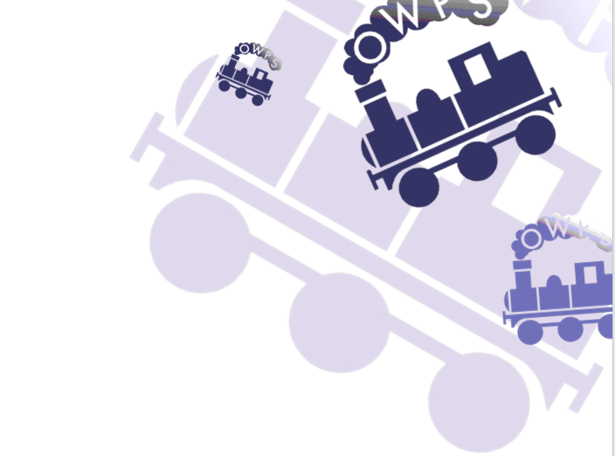

|  |  |  |  |  |  |  |  |  |
| --- | --- | --- | --- | --- | --- | --- | --- | --- |
| ORTON WISTOW PRIMARY SCHOOL CURRICULUM NEWSLETTER  |  |  |  |  | | --- | --- | --- | --- | | Academic Year: | 2024/2025 | Term: | Spring | | Year Group: | 4 | Topic Title: | Ancient Maya | |

| **Subject** | **Learning** |
| --- | --- |
| **English -** Reading | Our reading lessons will focus on two texts this term, The Lion the Witch and the Wardrobe by CS Lewis, and The Witches by Roald Dahl. We have selected these texts as an example of an archaic text (The Lion, the Witch and the Wardrobe), and because of the complexity of the narrator (The Witches).  In our English lessons, we will also be reading The Great Kapok Tree, by Lynne Cherry, and The Wild Robot, by Peter Brown. |
| **English** - Writing | Whilst studying our Power of Reading text ‘The Great Kapok Tree,’ we will explore the language associated with the rainforest, create poetry and perform drama, take part in debates and discussion about deforestation and write persuasively. We will finish off the unit by writing both formal and informal letters with a persuasive purpose.  In Spring 2, whilst studying our Power of Reading text ‘The Wild Robot’ we will explore and describe the remote island and the attitudes of the inhabitants towards the robot. We will analyse the features of newspaper reports, and build up text and sentence level skills to use when writing a newspaper report.  Children will be taught to use the following grammatical features and expected to apply these in written work across the curriculum: use of fronted adverbials, followed by a comma, using coordinating and subordinating conjunctions to join clauses and extend ideas, using apostrophes correctly and using inverted commas to punctuate direct speech.  Spelling rules taught will include: homophones and near homophones, words with the suffix -ation, words with the prefixes super- and sub-, words with a plural possessive apostrophe, words with a soft c spelt ce or ci, and word families based on common words. |
| **Mathematics** | In the first part of the Spring term, the focus will be Multiplication and Division. Children will learn:   * To find and use factor pairs for a number. * To multiply and divide by 10 and 100, and explain the effects of this. * To use written methods for multiplication and division.   Spring 1 will also include a unit in length and perimeter. Children will learn:   * To use units of length- metres and kilometres * To find the area of polygons and rectilinear shapes.   In Spring 2, Maths will focus on Fractions and Decimals. Children will learn to:   * Understand fractions as an equal part of a shape or number. * Use fractions and mixed numbers. * Understand improper fractions. * Add and subtract fractions. * Understand tenths and hundredths as decimals. * Divide 1 and 2 digit numbers by 10, giving the answer as a decimal. |
| **Science** | Throughout the Spring term we will be focusing on ‘States of matter’ and ‘Animals including humans.’  We will cover:  **Animals Including humans**  ● Digestive system parts  ● Digestive system functions  ● Types and functions of teeth  ● Tooth decay part 1  ● Tooth decay part 2  ● Food chains  **States of matter**  ● Solids liquid or gas  ● Investigating gases  ● Heating and Cooling  ● Wonderful water  ● Evaporation Investigation |
| **Computing** | In Information Technology, we will focus on spreadsheets. This will include:  ● Using number formatting tools  ● Adding a formula to a cell  ● Use data to create a line graph  ● Make practical use of a spreadsheet to help plan actions.  We will also use search engines to find out specific information and discuss the reliability of sources available on the internet. |
| **History** | Our topic for this term is ‘Ancient Maya’. This ancient civilisation will be explored through six main questions. As the term progresses the children will broaden their understanding of this topic by focusing on these questions:   * Why do you think we study the Mayan empire in school? * When the area they lived in was mainly jungle how on earth were the Maya able to grow so strong? * What was life like at the height of the Mayan civilisation? * How can we possibly know what it was like there 1,000 years ago? * If the Maya were so civilised why did they believed in human sacrifice? * How can we solve the riddle of why the Mayan empire ended so quickly?   As well as these important questions we will also be covering, food and drink, Mayan music, Mayan Language and Gods and religious beliefs. |
| **Geography** | In Geography this term will be exploring the world of ‘water’, we will be covering:  ● Changing state  ● The Water cycle  ● Making clouds and rain  ● Treating water  ● Flooding  ● Water pollution |
| **Art & Design** | In Art, our pathway will focus on exploring Still Life.  The following will be covered:   * What still life is and what are the features of this genre of Art. * Exploring the work of Still Life artists such as Paul Cezanne. * Using line, shape, colour, texture and form to support with composition and giving meaning to work. * Using painting and collage skills to create a Still Life composition. |
| **Music** | This term we will be learning to play the recorder, building on our learning in Year 3. We will:   * Revisit the notes B, A, G, and learn E and D. * Learn the names and values of musical notes. * Recognise where these notes are placed on the stave. * Learn and practise pieces of music using the notes learnt, playing as a whole class group. * Aim to perform our work to parents/ carers at the end of term. |
| **Design Technololgy** | In DT this term, the focus will be on food.  Children will:   * Understand where food comes from and be able to discuss the cycle of food production. * Understand which foods are grown and which are produced. * Investigate how food products have been created. * Learn how to cut, peel or grate ingredients safely and hygienically. * Assemble or cook healthy ingredients. * Create designs and evaluate finish products against design criteria.   We will be designing and making quesadillas! |
| **PE** | This term in PE we will be covering: Swimming (nighthawks only) , Football, Dance, Netball and Gymnastics. |
| **RE** | This term, our learning in RE will focus on Buddhism. We will look at the following six Big Ques**tions:**   * How do Buddhists follow the teachings of the Buddha in their daily lives? * How and where do Buddhists worship? * What are the Four Noble Truths and Noble Eightfold path and why are they important to a Buddhist? * Why is Dharma Day important to Buddhists and how is it celebrated? * Why is the Buddha an inspirational leader for Buddhists? * 6. What similarities and differences are there between our daily life and that of a Buddhist? |
| **MFL** | Our theme in French for this term is ‘Le Carnaval des Animaux’ (Carnival of the Animals). We will:   * Appreciate stories, songs, poems and rhymes in French. * Broaden vocabulary and develop ability to understand new words. * Describe animals and tell the time orally and in writing. * Develop accurate pronunciation and intonation so that others understand when they are reading aloud or using familiar words and phrases. * Present ideas and information orally. |
| **PSHE** | **Spring 1- Keeping Safe**  Children will learn to   * Identify trusted adults and approach them for support. * Assess the school and local environment from a personal safety perspective. * Understand safety rules and who and when to tell. * Identify and name body parts including the genital area. * Identify and distinguish between ‘yes’ and ‘no’ touches. * Distinguish between ‘good’ and ‘bad’ secrets. * Assess problems and risks to keep safer. * Use assertive voice and body language. * Recognise what makes a good listener and when it is the best time to tell.   **Spring One - RSE My Relationships**  Pupils are able to judge what kind of physical behaviours and contact are acceptable and unacceptable, and ways to respond.  **Spring 2- Economic Wellbeing**   * There are different ways to gain money, keep it safe, and pay for things. * To understand that individuals and families may choose to manage their money in different ways. * To understand different feelings about money. * To understand why charities exist and how they might help. * To make informed choices about how money is spent and keep track of spending.   **Spring Two - My Beliefs**  Pupils recognise differences and similarities between people arise from a number of factors including family and personal identity. |
| **Online-Safety** | E-Safety will continue into the Spring term, we will have two afternoons to cover different topics:  Our Online Tracks – We will explore digital footprints, and how these are changed by the choices people make when online. We will consider how to change their own and others digital footprints.  Keeping Games Fun and Friendly - Children will appreciate that some online games can be played by lots of people together at the same time. Pupils will understand that there are positives and negatives of social interaction in online games. We will investigate the responsibilities we have to make good choices if interacting with people online. |